**DAILY ONLINE ACTIVITIES SUMMARY**

|  |  |  |  |  |  |  |  |  |  |
| --- | --- | --- | --- | --- | --- | --- | --- | --- | --- |
| **Date:** | **09-06-2020** | | | | | **Name:** | **pallavi** | | |
| **Sem & Sec** | **6th sem ‘A’ sec** | | | | | **USN:** | **4al17cs056** | | |
| **Online Test Summary** | | | | | | | | | |
| **Subject** | | **CGV**  **CNSC** | | | | | | | |
| **Max. Marks** | | **CGV:30**  **CNSC:60** | | **Score** | | | **CGV:27**  **CNSC:45** | | |
| **Certification Course Summary** | | | | | | | | | |
| **Course** | **Python for machine learning** | | | | | | | | |
| **Certificate Provider** | | | **Great learning academy** | | **Duration** | | | **5hr** | |
| **Coding Challenges** | | | | | | | | | |
| **Problem Statement:**   1. Rotate the matrix by K times means rotating the given NN matrix to the specified (K) number of times. For example, consider the 33 matrix, which has to be rotated once. 2. Given an array arr[] of integers and an integer K, the task is to print all subsets of the given array with the sum equal to the given target K. 3. write a java Program to print smallest and biggest possible palindrome word in a given string 4. Write a Python program to count the number of even and odd numbers from a series of numbers.   5.Write a Java Program to remove all white spaces from a string without using replace() | | | | | | | | |
| **Status:completed** | | | | | | | | | |
| **Uploaded the report in Github** | | | | | **yes** | | | | |
| **If yes Repository name** | | | | | <https://github.com/pallavi056/DAILY_STATUS> | | | | |
| **Uploaded the report in slack** | | | | | **yes** | | | | |

Online Test Details:

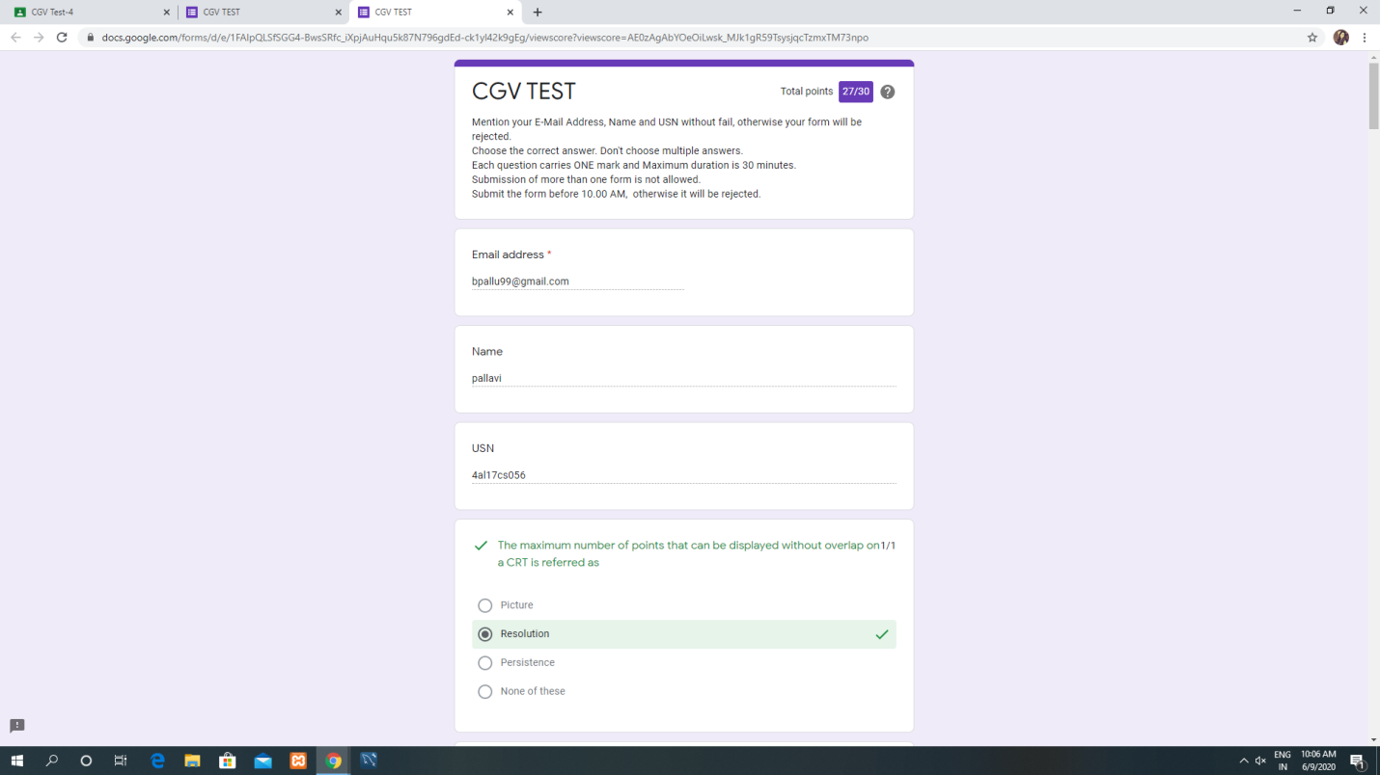

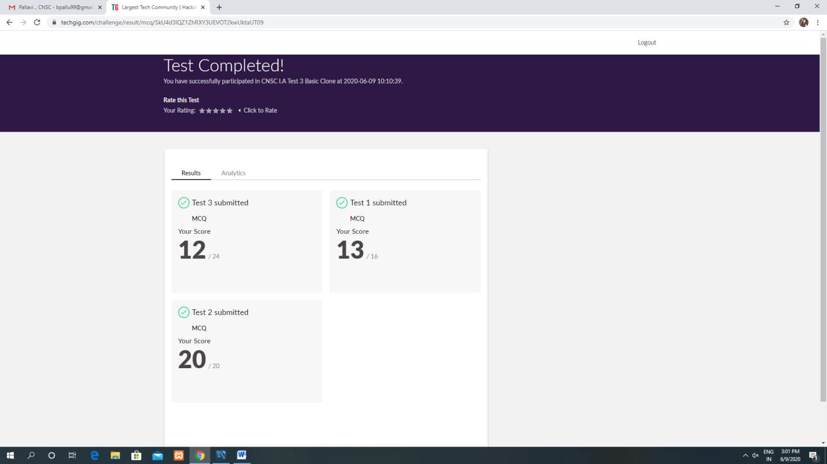

Certification Course Details:

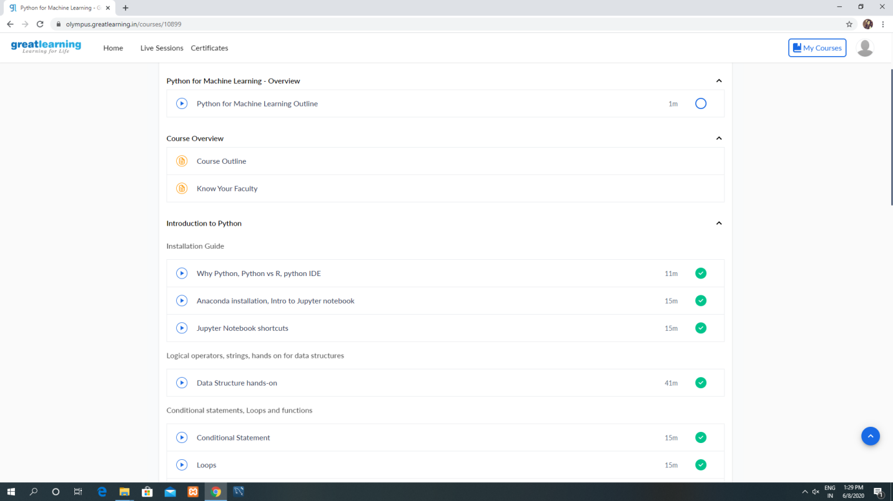

Coding Challenges Details:

[https://github.com/pallavi056/DAILY_STATUS/tree/master/09-06-2020/ONLINE%20CODING](https://github.com/pallavi056/DAILY_STATUS/tree/master/09-06-2020/ONLINE CODING)